DAY 18: EVENING ASSESSMENT

13.Simple props – Create a Greeting component that takes name as a prop and displays "Hello, {name}!".  
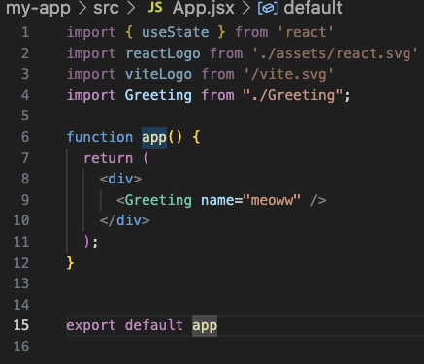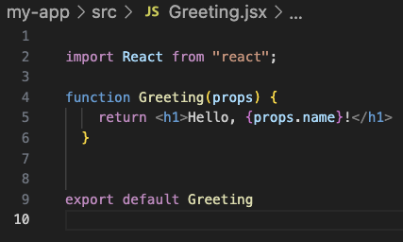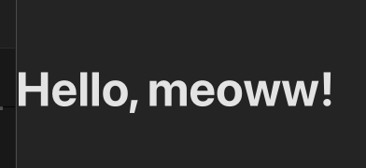

14.Display a variable value – Store your favorite color in a variable and show it in <h1>.

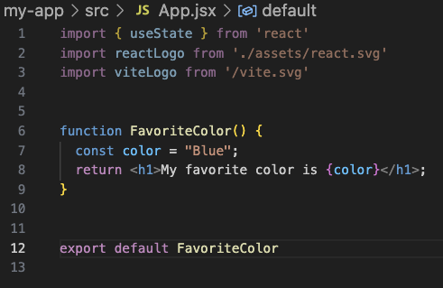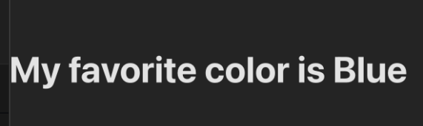

15. Display a variable value Store your favorite color in a variable and show it in <h1> .



16. Add two numbers Store two numbers in variables and display their sum.

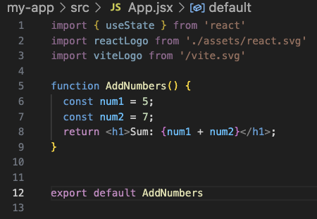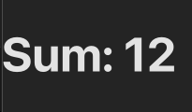

17. Props example Create a Hello component that shows "Hello, {name}" where name comes from props.

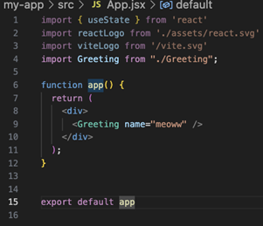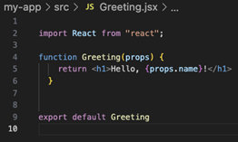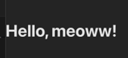

18. Click alert Create a button that shows an alert "Hello React" when clicked.

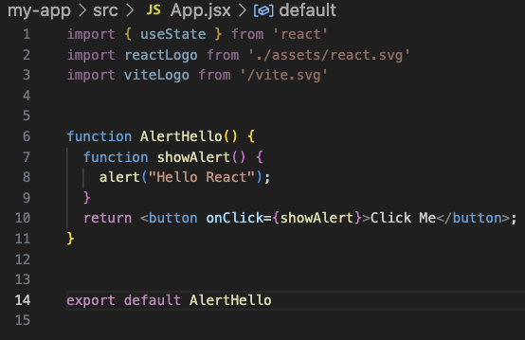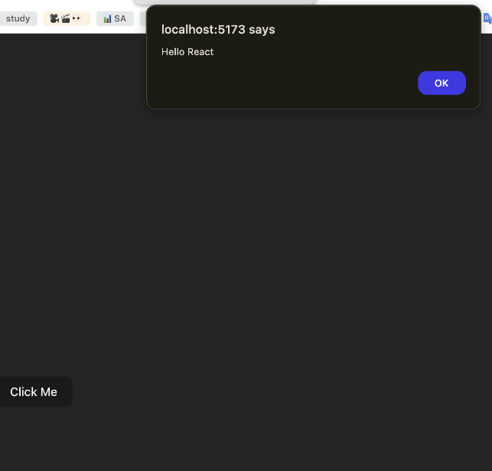

19. Click alert Show an alert saying "Welcome to React" when a button is clicked.

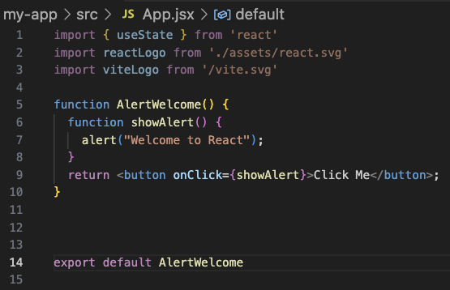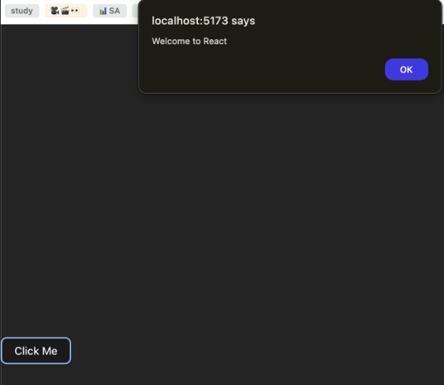

20. Show text on click Display a heading "Click the button" and below it a message "Button was clicked!" when clicked (message can be hardcoded).

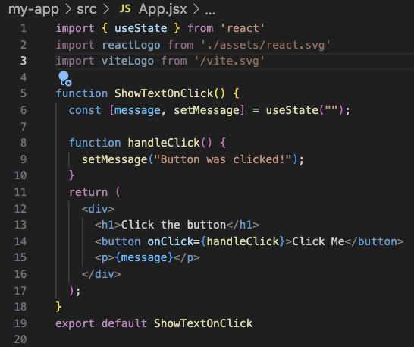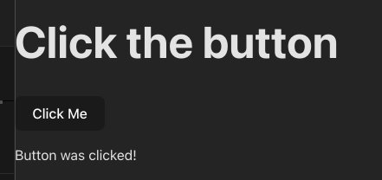

21. Show a variable in JSX Create a variable city = "Hyderabad" and display it in a heading

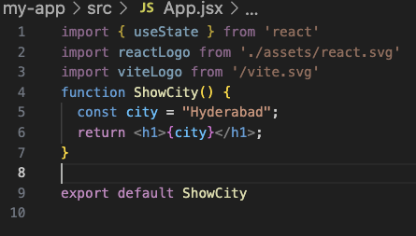

22. Math in JSX Display the result of 10 \* 2 inside a heading.

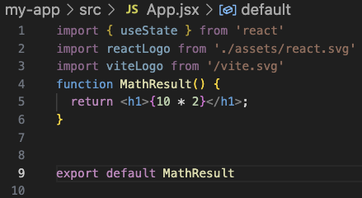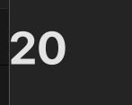

23. Function return in JSX Create a function getMessage() that returns "Welcome" and display it inside a heading.

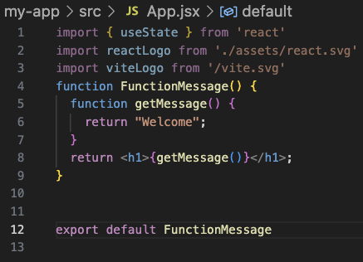

24. Alert on click Create a button that shows an alert saying "Button clicked!" when pressed.

